Dustin Kendall

kendalld@pnw.edu

Abstract

An implementation of ARMv4 in VHDL

Lab 6

ECE 371 Single Cycle ARMv4

# Marked Up Datapath Schematic



# Table



# VHDL

## Modification of DMEM to Load Bytes

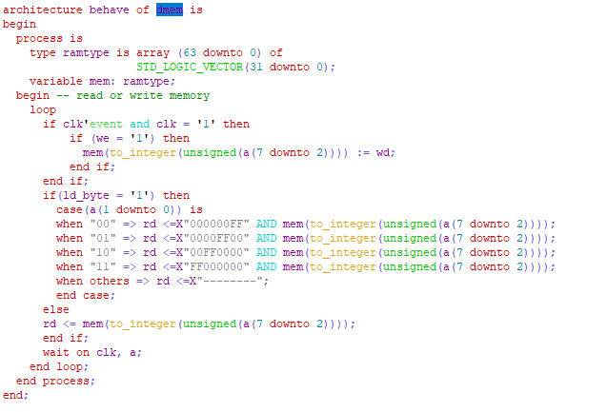

## Modification of decoder to support new ALU operation

## 

## ALU Modification to Support exclusive-or

## 

## New Shift Register

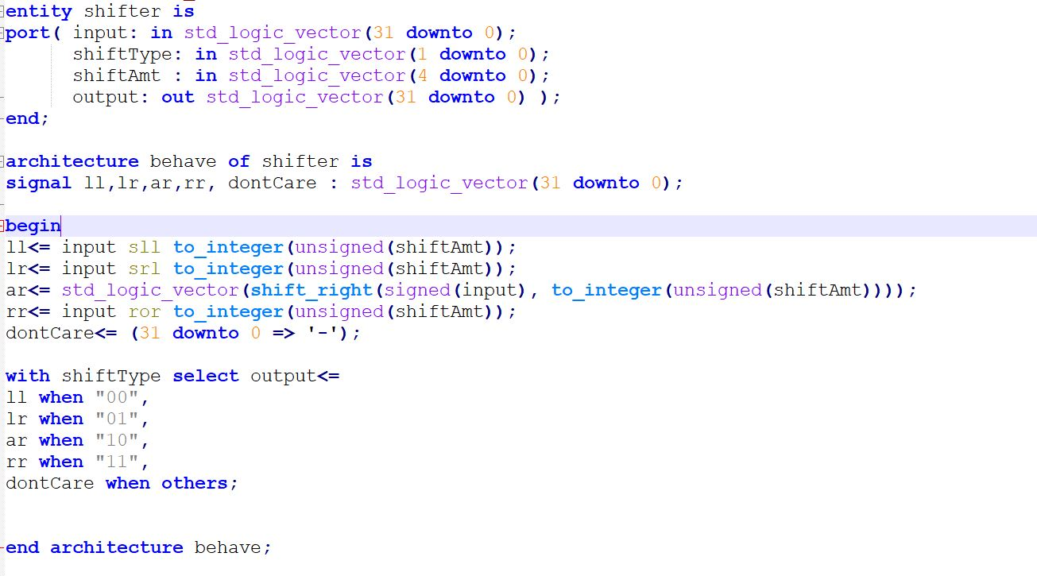

## Shift Register Instatiation

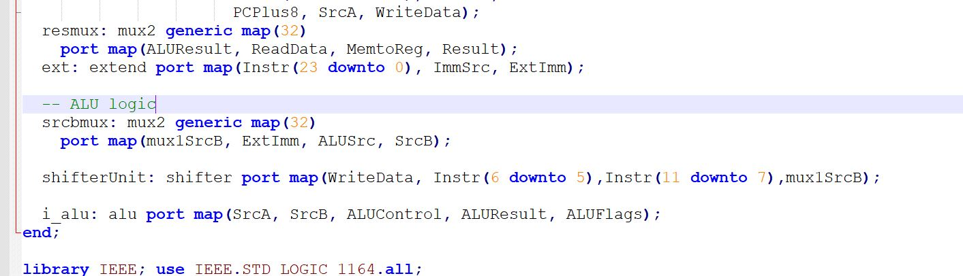

# .DAT Files

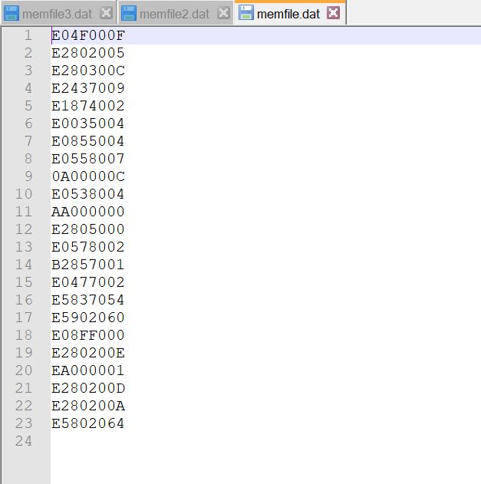

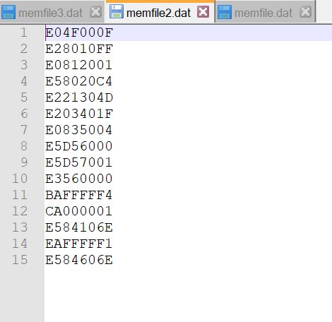

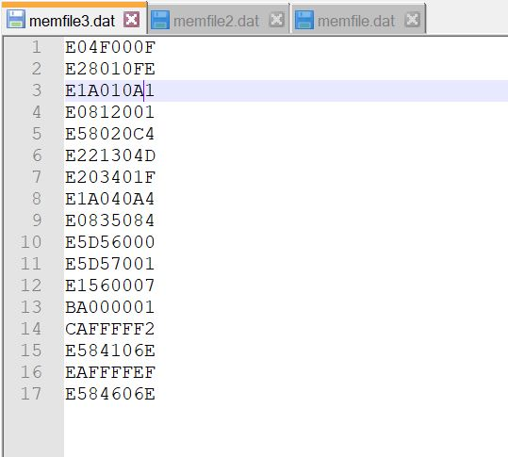

# Simulation Results

## Part 1 Simulation

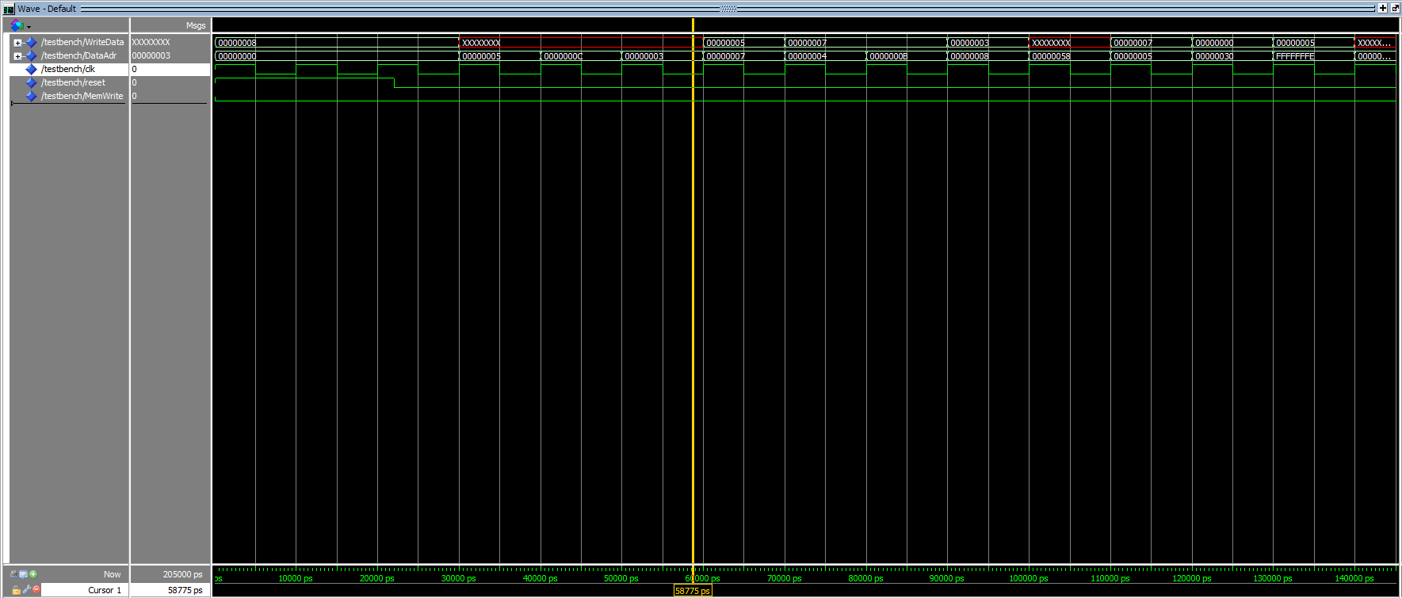

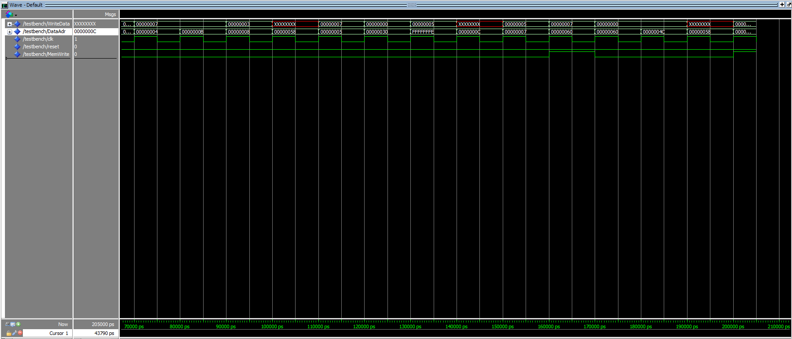

## Part 2 Simulation

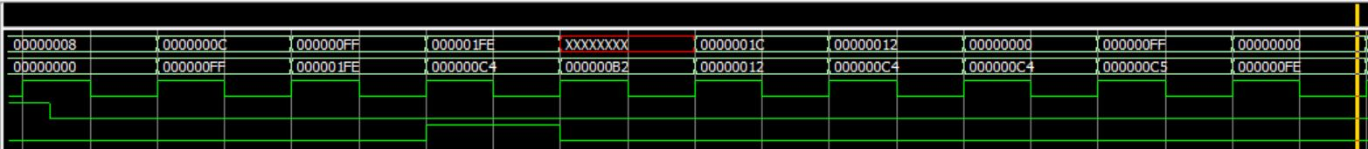

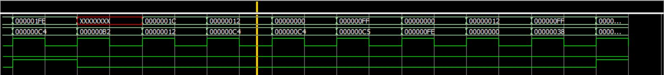

## Part 3 Simulation

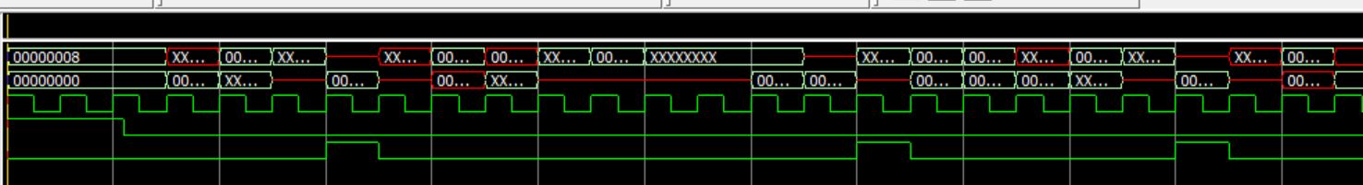

# Conclusion

All values seemed to correspond correctly. I just don’t understand why the out put of write data is sometimes incorrect or uninitialized. It was this way in a couple places.